Python Project Documentation
Prepared by: Youssef Wael ID: 246977

Youssef Adel ID: 247121

Introduction:
This document provides an overview of the Python project, outlining its purpose, functionality, and implementation.
The project aims to analyze data and automating tasks.

Visualizations:

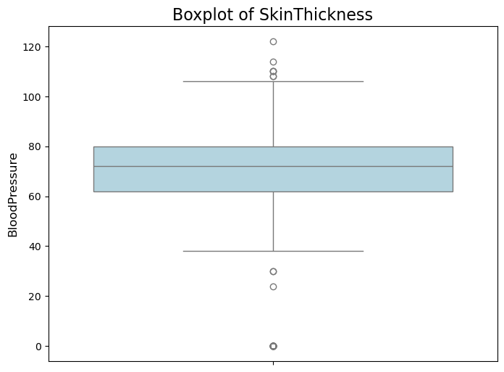

Blood Pressure: The boxplot for blood pressure shows a relatively normal distribution with no extreme outliers.

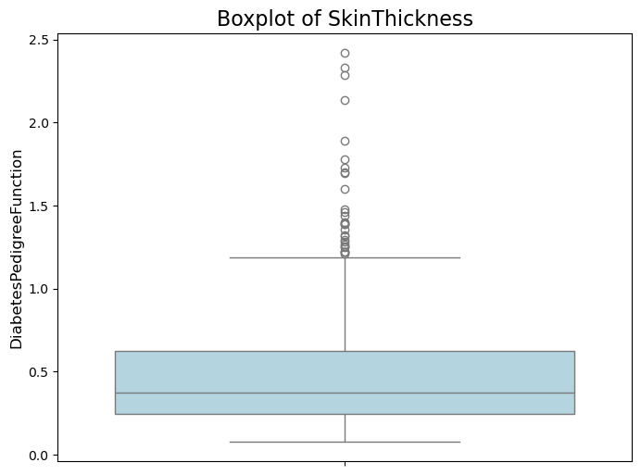
DiabetesPedigreeFunction: The boxplot shows that most values are clustered near the lower end, indicating that most individuals have lower diabetes pedigree function values.

- Correlation Matrix (Heatmap)
• A heat map was used to showcase the correlations between features. Glucose and Outcome featured a strong positive correlation as did BMI and Insulin.
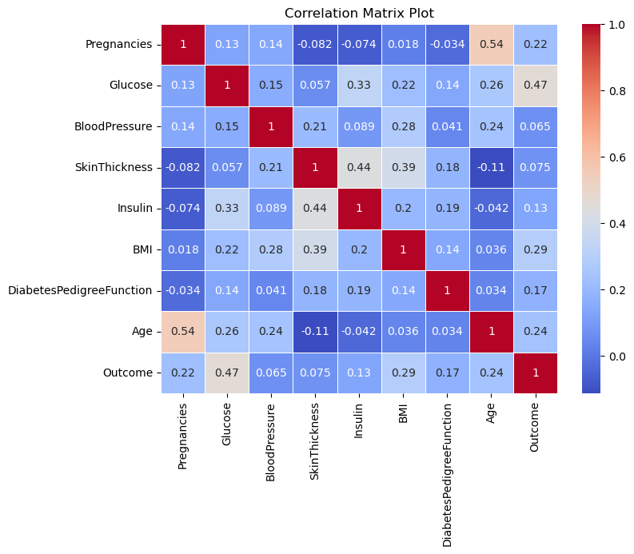
Scatter Plot (Blood Pressure vs. BMI)
- A scatter plot was created to explore the relationship between Blood Pressure and BMI. The plot shows a weak correlation, with data points scattered across the chart.

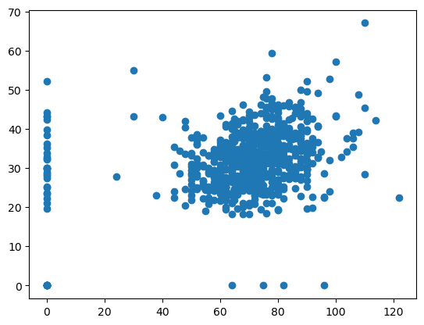

Pregnancies: The histogram shows that most individuals in the dataset have had 0 to 5 pregnancies, with a relatively small number having more than 5 pregnancies.
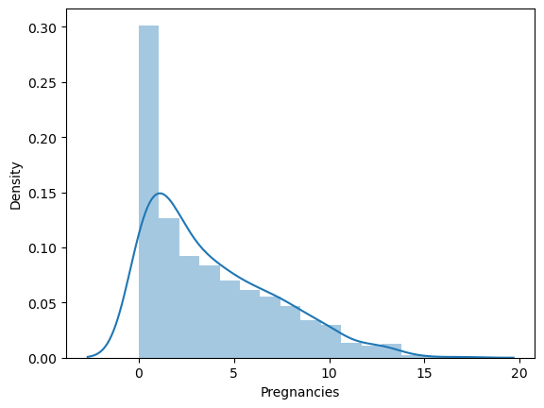
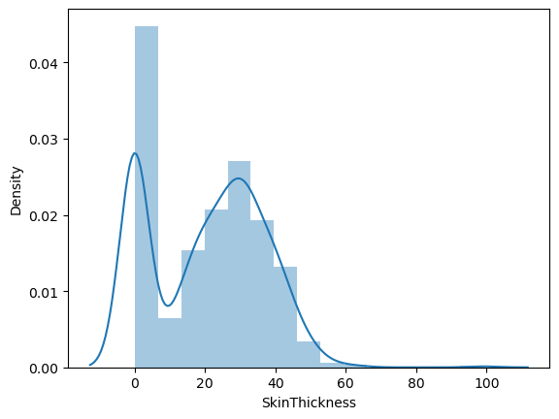
Skin Thickness: The distribution plot reveals that skin thickness values are heavily skewed, with many individuals having lower values (including zero), which could indicate missing data or outliers.

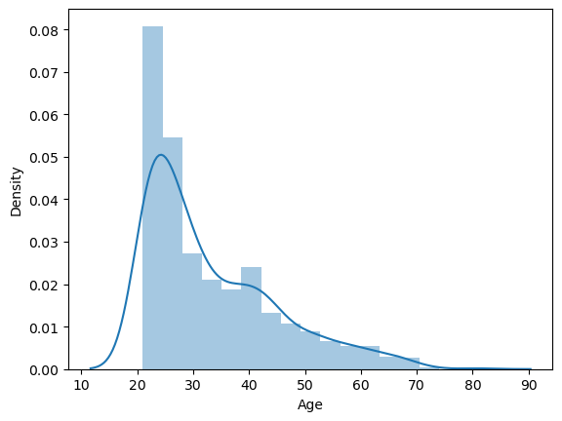

Age: The age distribution plot shows that most individuals in the dataset are younger adults, with fewer individuals in the older age ranges.
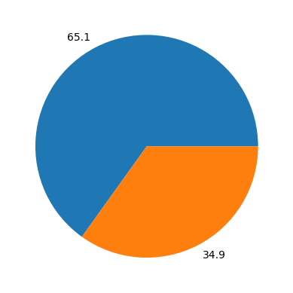
Pie Chart (Outcome)
- A pie chart visualized the Outcome feature, showing that the majority of individuals do not have diabetes, with a smaller proportion having been diagnosed.
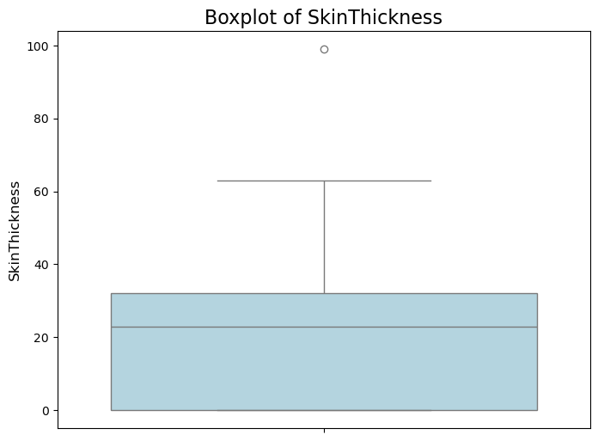

Skin Thickness: The boxplot shows a wide range of values, with potential outliers in the lower range (values close to 0), which might represent missing or erroneous data.

Data structures

1. Mean Values (Average)
Represents the central tendency for each feature.
• Pregnancies: 3.85
• Glucose: 120.89
• Blood Pressure: 69.11
• Skin Thickness: 20.54
• Insulin: 79.80
• BMI: 31.99
• DiabetesPedigreeFunction: 0.47
• Age: 33.24
• Outcome: 0.35
2. Median Values
Represents the middle value when the data is sorted.
• Pregnancies: 3.00
• Glucose: 117.00
• Blood Pressure: 72.00
• Skin Thickness: 23.00
• Insulin: 30.50
• BMI: 32.00
• DiabetesPedigreeFunction: 0.37
• Age: 29.00
• Outcome: 0.00
3. Standard Deviation
Measures of how spread out the values are from the mean.
• Pregnancies: 3.37
• Glucose: 31.97
• Blood Pressure: 19.36
• Skin Thickness: 15.95
• Insulin: 115.24
• BMI: 7.88
• DiabetesPedigreeFunction: 0.33
• Age: 11.76
• Outcome: 0.48
4. Variance
Represents the square of the standard deviation, providing another measure of spread.
• Pregnancies: 11.36
• Glucose: 1022.51
• BloodPressure: 374.78
• SkinThickness: 254.40
• Insulin: 13291.26
• BMI: 62.10
• DiabetesPedigreeFunction: 0.11
• Age: 138.26
• Outcome: 0.23
________________________________________
Insights and Significance:
1. Pregnancies:
o Standard deviation of 3.37 and a variance of 11.36 preclude moderate variability. While most of the people are closer to the mean of 3.85 pregnancies, there are cases with higher numbers of pregnancies that affect the overall dataset.
2. Glucose:
o\tThe high standard deviation of 31.97 and variance of 1022.51 indicate significant variability in glucose, which may be important in analyzing diabetes since outliers might reflect those individuals who have greater health risk.
3.
BMI (Body Mass Index):
o\t The BMI has a standard deviation of 7.88 and therefore, weight and level of obesity are variable. Variance is 62.10 and hence, analyzing weight becomes an important diabetes factor
4.
Skin Thickness & Insulin:
Both features have high standard deviation values, 15.95 and 115.24 for SkinThickness and Insulin, respectively. This might indicate that there is significant dispersion or even outliers. The zero values discussed above may be influencing this dispersion and may need some preprocessing to gain more insight.
5. Age:
o with a standard deviation of 11.76, the dataset contains a wide range of ages, with an average of 33.24 years.
6. Outcome:
o\t The standard deviation of 0.48 and the variance 0.23 for outcome prove that the dataset is really well balanced between the instances of individuals with and without diabetes, or 0 and 1.

